Cheat Sheet for Test 10- Science
absorb amplitude concave mirror convex mirror crest
electromagnetic wave frequency laser lens
light longitudinal waves microwaves mirror
opaque pigments
primary colors radio waves reflection refraction
speed of waves translucent transparent transverse wave
trough ultraviolet rays visible spectrum wavelength

Be sure to understand and how to label a transverse wave
Be sure to understand the use of ultraviolet light
Be sure to understand reflection and absorption of light.

BJU Science Notes Chapter 10
- Light Energy
    - Light Energy
      - Light: is a ______________________ of _____________________ energy.
      - waves carry _____________________
      - light travels through _____________________ and empty _____________________. Because light can travel through _____________________, we receive light from the _____________________.
      - light waves moves _____________________ than other types of _____________________. The speed of light is _____________________km/sec. or 186,000 mi/sec. It takes _____________________minutes for the suns rays to reach the earth.
    - Comparing Waves: Scientists compare waves by what it can move through _____________________ _____________________ or in which _____________________ they can move.
      - Electromagnetic waves: are waves that can move through _____________________. Light is an electromagnetic wave.
      - Mechanical waves: are waves that only move through _____________________. Sound is a mechanical wave.
      - Longitudinal waves: waves that move in the same_____________________ as the _____________________ is _____________________. _____________________ is a longitudinal wave.
      - Transverse waves: waves that move _____________________ to the way that the _____________________ is moving. _____________________ is a transverse wave.
    - Properties of Waves there are _____________________ basic properties of waves. They are: _____________________, _____________________, frequency and speed.
      - Wavelength: the distance between two_____________________ or two _____________________.
        - Crest: the _____________________ point of a _____________________ wave.
        - Trough: the _____________________ point of a _____________________ wave.
      - Amplitude: the _____________________ of a wave from its _____________________ position to its _____________________ or _____________________.
      - Frequency: the number of _____________________ that pass a certain point in _____________________.
        - long wavelengths have _____________________ frequencies
        - Short wavelengths have _____________________ frequencies.
      - Speed: the _____________________ that one wave _____________________ in one _____________________.

- Visible Spectrum:
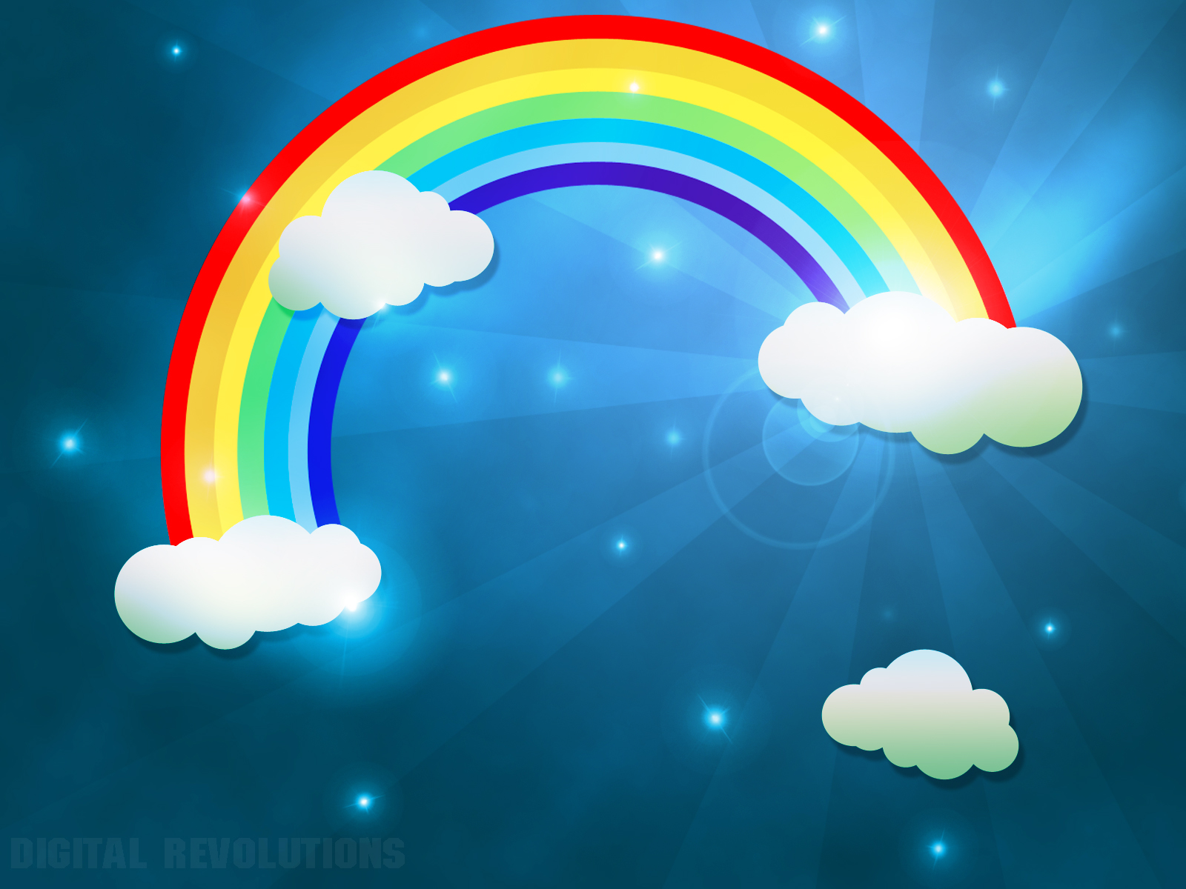
      - Without _____________________ there is no _____________________.
      - The visible spectrum is the_____________________ _____________________ of light that are separated from _____________________ _____________________.
A. Refraction and Reflection
      - Light travels in a _____________________ _____________________.
      - Light can travel through different _____________________.
        - A medium is _____________________ through which a _____________________ travels through.
        - the speed of light changes as light enters different mediums
        - Light travels _____________________ through _____________________ _____________________.
        - The only thing that changes in light is the _____________________ and the _____________________. Regardless of the media that it travels through, light always travels in a _____________________ _____________________.
      - Refraction: the _____________________ of_____________________ as it passes from one medium to another. (Think about a pencil in water).
      - The visible spectrum’s color is in order of its wavelengths. Red has the longest wavelength. This is why the rainbow looks as it does.
      - ROY G. BIV: The way you can remember the colors of the _____________________ _____________________. the colors are red, _____________________, yellow, _____________________, _____________________, _____________________ _____________________
        - Transparent and translucent objects: are able to _____________________ light. Transparent means that it can be seen through like a prism, water, or a window.
        - Translucent means that it allows________________ to shine through, but diffuses the light so that objects can’t be seen clearly. (Like frost on glass).
        - Reflection is the _____________________ back of _____________________.
        - Opaque: items that don’t allow _____________________ to pass through them. they _____________________ or _____________________ in some _____________________ of light.
    - Combining Colors
      - Primary colors of light: the primary colors of light are different from the primary colors of art. The primary colors of light are _____________________, _____________________ and _____________________. _____________________ colors cannot be _____________________ from other _____________________. The actual primary colors of art are magenta, _____________________ and _____________________.
      - When equal amounts of the primary colors are combined, _____________________ light is created.
    - Mirrors
      - mirror: any _____________________ that can _____________________ light to form an _____________________, or _____________________, of an object.
      - There are _____________________ types of _____________________. Plane, _____________________ and _____________________.
        - Plane mirror: mirror with a _____________________ surface. The image of an object reflected from a plane mirror looks _____________________ like the original, just _____________________.
        - Concave: curves _____________________. It makes the image _____________________. This makes images that are _____________________ away look _____________________. They are used in dental _____________________, makeup mirrors and, in _____________________.
        - Convex: curves _____________________. It makes images look _____________________. They are used in stores to watch _____________________ and as side _____________________ on vehicles.
- Light and Technology
      - Lens: a piece of _____________________ or other _____________________ object that _____________________ light and _____________________ an image.
      - Telescopes: are used to see things that are _____________________ _____________________ such as _____________________ and planets.
        - In order to collect and focus light, telescopes use _____________________, _____________________ or a combination of _____________________ of these.
        - There are _____________________ main types of telescopes. They are _____________________ and _____________________ telescopes.
      - Cameras also use _____________________ and _____________________.
        - A single-lens reflex camera uses a _____________________, _____________________, and _____________________ to collect and focus _____________________.
        - an example of a single-lens reflex camera is a _____________________ camera
      - Lasers: are _____________________,_____________________ beams of light . They use _____________________ and a medium such as a _____________________, _____________________ or gas for the light to travel through. What is unique about the color of a laser is that it can only be _____________________ _____________________. The color of the _____________________ is determined by the type of _____________________ used.
        - Lasers are used for reading _____________________ or _____________________, doing _____________________, cutting _____________________or _____________________.
        - The laser exits the tube that it is located in by “_____________________” out.
        - it is not a good idea to point a _____________________ at yours or any one elses_____________________ because it could damage your or their_____________________ .
    - Longer than Light
      - light is an _____________________ wave that we can _____________________.__________________________________________ come from the _____________________ and other sources. There are _____________________ that we cannot see.
      - All _____________________ waves travel at the same _____________________ however; they have different _____________________ and _____________________.
      - When they are arranged in order of _____________________, they are called the _____________________ spectrum.
      - radio waves are the _____________________ kind of electromagnetic wave
        - They carry energy to broadcast _____________________ and _____________________.
        - These waves do not come out of a radio. They are _____________________ to an _____________________ where they are changed into _____________________.
        - Radio waves are used in _____________________ _____________________openers, remote _____________________ ____________________, baby_____________________ and _____________________-_____________________ collars.
      - Microwaves: are the next waves in the _____________________ spectrum.
        - Some uses for these are: _____________________ ovens, _____________________ _____________________, and _____________________.
        - Some uses for radar are: to check the _____________________ of _____________________, direct _____________________, to locate ships at _____________________ and to track _____________________ systems.
      - Infrared: waves are located _____________________ to _____________________ light. _____________________ objects give off more _____________________ waves than _____________________ objects. Scientists see things when there is no _____________________ light by using a _____________________ camera.
    - Shorter than Light
      - the electromagnetic waves that have shorter wavelengths than light are _____________________, _____________________, and _____________________ rays.
      - _____________________ are just a little shorter than violet rays.
        - ultraviolet rays are used to make some things _____________________ in the _____________________, detecting _____________________, killing _____________________ in food or in _____________________ equipment.
        - it is helpful for your skin because it helps your skin to produce _____________________.
        - it can be a threat to your skin when having too much as it can cause _____________________, skin _____________________, _____________________ cancer, and _____________________.
          - to protect your skin it is helpful to use _____________________ with a high _____________________.
          - SPF stands for _____________________ _____________________ _____________________.
          - People can still get sunburned on overcast days because the ultraviolet rays still pass through the clouds even though the visible sunlight is trapped by clouds.
      - X-rays: some sources of x-rays are: things in _____________________, stars and _____________________.
        - X-rays are used in _____________________, art, industry and _____________________.
        - A person who is overly exposed to x-rays can develop _____________________.
          - To avoid this doctors and dentists use special _____________________ coverings to keep them safe.
          - in art x-rays are used to _____________________ paintings
          - In engineering they are used to check for _____________________ in steel or concrete structures.
          - Airports use x-rays for _____________________ and to check _____________________.
      - gamma rays: the _____________________ electromagnetic waves.
        - they are prevented from reaching the earth with the help of the _____________________ _____________________ in the _____________________.
        - gamma rays can be _____________________ and _____________________.
          - because we don’t know everything about electromagnetic waves, we have to use these types of waves very carefully.
          - they can be helpful by helping to treat some kinds of _____________________, to _____________________ bacteria in some kinds of _____________________, sterilize medical equipment and bandages.

